Name: Chimzim Ogbondah
Section: 9
University ID: 273362113

Lab 2 Report
Fill out this report using MS Word or a compatible program. Please do NOT submit a handwritten report.
Summary:
Through the process of this lab I was able to better understand different linux commands. In Experiment two which touched on the fork() command I gained a better understand of how it works where it executes both the child and parent process at the same time and how PPID and PID is related when fork() is called. My knowledge further on the command in experiment 3 where conditional logic was used to differentiate the child and parent process. This helped me understand why it is useful for the child to return a different value than the parents but also why the PID of the child should be returned (to know which child). In experiment 4 I got to understand and mess with OS scheduling and then in 5 using the wait command to see how the use of wait() omits the anomalies seen in experiment 4. I also now see how to kill a process using kill() which is different from the exit() command used to terminate the entire program as well as how the exec command changes the nature of a function based on the arguments given and type.

Lab Questions:

3.1:
6pts In the report, include the relevant lines from “ps -l” for your programs, and point out the following items:
- process name
- process state (decode the letter!)
- process ID (PID)
- parent process ID (PPID)
2pts Repeat this experiment and observe what changes and doesn't change.
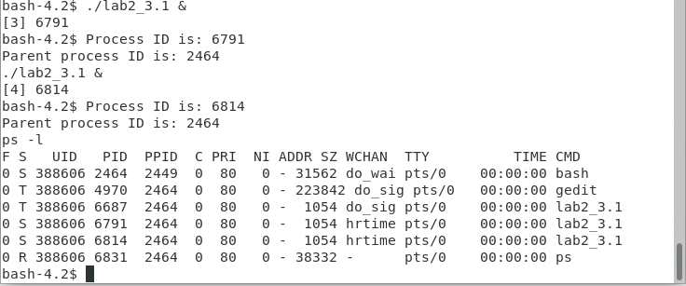
2pts Find out the name of the process that started your programs (the parent). What is it, and what does it do?
The PID changes whenever I rerun the experiment however the PPID always stays the same at 2464 and the UID at 388606
The first process that starts it comes from the gedit/lab2_3.1 this file returns the process ID and then states the parent ID after and then sleeps for 2 minutes before printing I am awake. Because of the exercise it prints “I am awake twice”
3.2:
1pt Include the output from the program
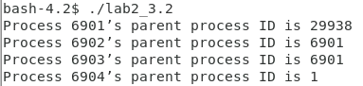

4pts "Draw" the process tree (the nodes should be PIDs)
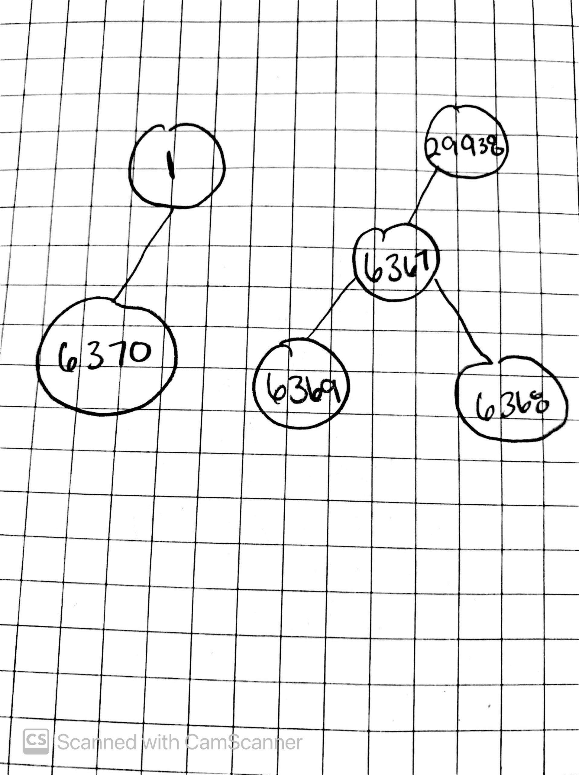

3pts Explain how the tree was built in terms of the program code
2pts Try the program again without sleep(2). Explain what happens when the sleep statement is removed. You should see processes reporting a parent PID of 1. Redirecting output to a file may interfere with this, and you may need to run the program multiple times to see it happen.
Calls fork the first time which makes the child process and parents. Then it calls fork again in which another parent and child process is created but the second fork happens inside of the parent process hence when the parent has two children.
When you remove sleep(2) it alternates between having the last child process have a PPID of 1 and being connected to the parent of the child process. Example 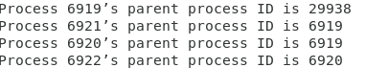

3.3:

2pts Include the (completed) program and its output
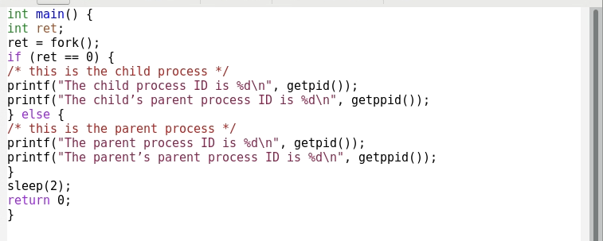
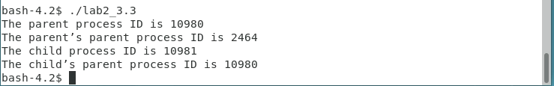
4pts Speculate why it might be useful to have fork return different values to the parent and child. What advantage does returning the child's PID have?
It is useful for fork() to return different values for the child and parent process because then you can differentiate which processes is the child and which is the parent as the parent would be waiting for the child to do some process. Returning the child’s PID ensures that you know which child process is which since a parent can have many children
3.4:
2pts Include small (but relevant) sections of the output
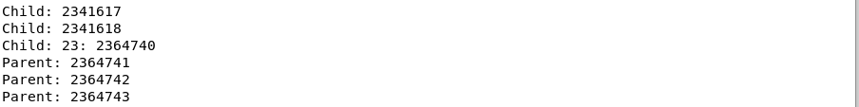

4pts Make some observations about time slicing. Can you find any output that appears to have been cut off? Are there any missing parts? What's going on (mention the kernel scheduler)?
Then end of my program is missing outputs. I also noticed that it switches back and forth between Child and Parents with the child printing and then stopping before finishing and going to the parent.

3.5:
6pts Explain the major difference between this experiment and experiment 4.
Be sure to look up what wait does (man 2 wait).
So in experiment 4 as you went up in iterations the parent process would start before the child process ended but in the current experiment given the wait(Null) line the program code the parents process won’t start until the termination of its child process
3.6:
2pts The program appears to have an infinite loop. Why does it stop?
Because the fork() returns the PID in the parent process and 0 in the child process. In this case it returns the PID of the child. Hence why it takes the else condition. The parent process then sleeps for 10 seconds which allows the child process to run until it wakes up which it then promptly kills the child process ending the infinite loop
4pts From the definitions of sleep and usleep, what do you expect the child's count
to be just before it ends?
2pts Why doesn't the child reach this count before it terminates?
Usleep() is in microseconds whereas sleep is in seconds so if you take 10/0.01 = 1,000 so it should be around a count of 1,000
Not everything works out perfectly.

3.7:
8pts Read the man page for execl and relatives (man 3 exec). Under what conditions is the printf statement executed? Why isn't it always executed?
(consider what would happen if you changed the program to execute something other than /bin/ls.)
Execl() changes the process at hand so, the printf statement is not executed if the first argument remains “bin/ls”. Since the second argument is “ls” it will look for that in the file path. When present it prints out the files in the working directory and when not present prints out the statement “what happened”.
3.8:
2pts What is the range of possible exit status values printed for the child process?
2pts What is the signal value the child process uses to terminate itself, as determined and printed by the parent process?
0-255
2pts When do you think the return value of main() would be useful?
15

Hint: look at the commands true and false.
It would be useful to determine failure. We should get a value other than 0 if the program ran successfully.

